Olympics Day 2018
Each event you compete in earns you Homebase points

Date: Friday 23rd February.

Time: 8:40am – 3:00pm.

Venue: Rannderdale Playing Fields (71 Suva Street).

Expectations: Students are expected to remain onsite all day. This is a fun compulsory school event. Students must bring their own food as they will not be able to leave to buy lunch. Groups may be doing their own fundraisers so some food will be available to buy on site. Water and sunscreen will be available to fill up drink bottles throughout the day. Students should bring both hats and warm clothes in case of weather extremes.

Transport and Venue: A map is attached illustrating where the Middleton Grange School Field is. Students are expected to make their own way there and will be released from the grounds at approximately 2:45pm. Events begin at 9:00am so students need to be there by 8:40am for the roll check.
A number of buses can be caught to the Bush Inn Centre. The Rannerdale Playing Fields are a 5 minute walk away.

Help Needed: If any parents can help in any way on the day please email: physical.education@unlimited.school.nz
Any help will be greatly appreciated.

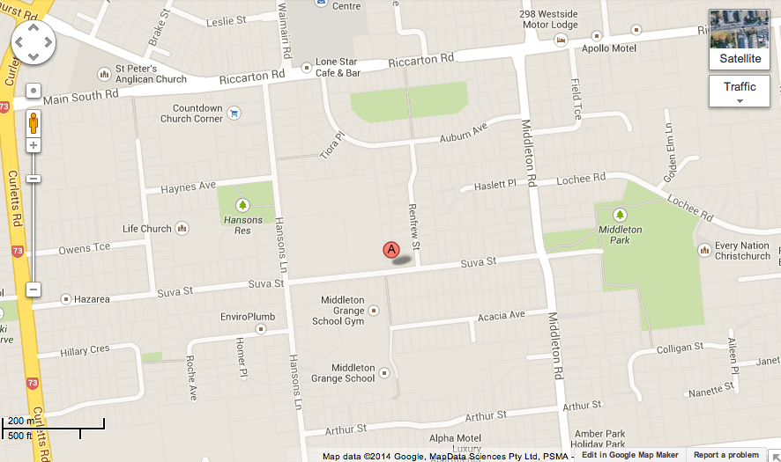
Bush Inn Centre
MIDDLETON GRANGE SCHOOL FIELD
CHURCH CORNER COUNTDOWN

